457.557 Water Resources Systems Engineering, Spring 2022
Quiz #1, Mar-29, 2022 (30 mins, 40 pts total)
Student Number: ___________________ Name: ___________________

I) Multiple Choice Questions (3 pts each, 6 pts total)
- What component is not included inside a simulation model?
- Decision Variables
- Constraints
- Objective Function
- None of the above

- If you want to be returned with $1,000 10 years from now, how much should you save today in a saving account with 8% compound interest rate? (${1.08}^{10}=2.16$)
- $423
- $463
- $503
- $543

II) Short Answers (7 pts each, 14 pts total)
- (a) Fill in the blank:
Water resources systems analysis problems are often called as ________________ problems, since defining the problem is the problem itself.
(b) Write at least two reasons why WRSA problems are difficult so solve.

- What is the meaning of the Lagrange multiplier? What can be inferred from the value of the Lagrange multiplier in an optimization problem? You may include equations and variables in your solutions if necessary.

III) Problem Solving (10 pts each, 20 pts total)
- (a) Given the changing inflows and constant outflow from a tank or reservoir, as shown in the graph below, sketch a plot of the storage volumes over the same period of time, beginning at 150.
(b) What are the governing equation and the assumptions in this model?
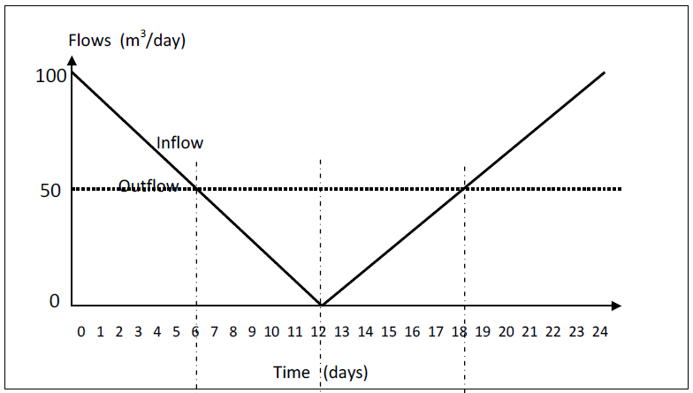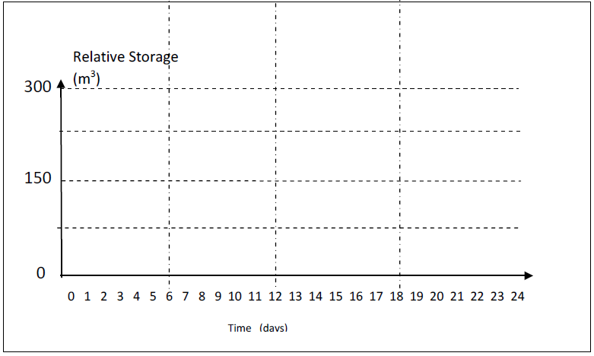
Governing Equation & Assumptions:

- Consider the following problem (Mays & Tung p. 140):
Minimize ${(x_{1}-1)}^{2}+{(x_{2}-2)}^{2}$
Subject to:
$$x_{1}-{2x}_{2}=0$$
Use the method of Lagrange multipliers to solve this problem. (i.e. What are the optimal values of $x_{1}^{*},x_{2}^{*}, and λ$?)

Sudoku for Early Finishers
